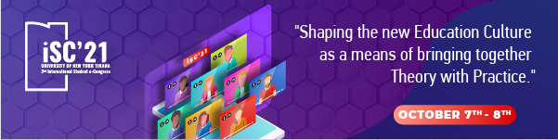
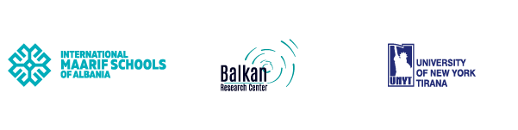
UNIVERSITY OF NEW YORK TIRANA
EUROPEAN AND BALKAN RESEARCH INSTITUTE
2ND INTERNATIONAL STUDENT e-CONGRESS ON SOCIAL AND APPLIED SCIENCES
OCTOBER 7th – 8th, 2021

Call for Abstracts
“Shaping the new Education Culture as a means of bringing together Theory with Practice.”

Following the success of the First International Student e-Congress, we invite you to the Second International Student e-Congress on the topic “Shaping the new Education Culture as a means of bringing together Theory with Practice” this 7th & 8th of October 2021.

Submit your Abstract

 | Important Dates
 | Deadline for Abstracts: | August 31st, 2021
 | Congress Date: | October 7^{th –} 8th, 2021
 | Deadline for Full Paper Submissions: | October 31st, 2021
 | *Early bird registration: Save your seat for free by submitting your abstract before August 31st
Check for the Book of Abstracts of the previous Congress as well as the IJBS, 1st Vol., Sept. 2020 – the first volume of the International Journal of Balkan Studies, where the Students’ papers were published.

FIELDS AND THEIR TOPICS:
- COMPUTER SCIENCES
  - Are we late to digitalization: how professions can be performed and transformed as a stay-at-home employee?
  - Women in Technology.
  - Challenges of cybersecurity during COVID-19.
  - Does technology connect us more or divides us more?

- ECONOMY AND BUSINESS
  - Diversity, Equity and Students’ success in the new economic conditions
  - Market Saturation, lack of good jobs and depression.
  - Games for Change: how education and business may come together.

- POLITICAL, SOCIAL AND CULTURAL STUDIES
  - Political changes and the roles that they play to the youth
  - Are young people interested in the political life?
  - Social transformation and the role of education to prepare the young people.
  - How cultural changes and education affects the future development of students.

- EDUCATION AND PSYCHOLOGY
  - Beginning a new decade with new approaches: An attempt to answer big questions!
  - The education system in the developing countries, how the mindset and culture impose education's "demand and supply".
  - The difficulties during the COVID-19 pandemic and the quality of the students in the after-education process.
  - The difficulties COVID-19 has imposed on learning and teaching through online education and the acceleration of the "Cheating" culture
  - Psychological motivation during a lock-down.
  - The challenges of choosing a place to settle down after graduation.
  - Skills and talents: how education promotes youngsters.
  - The difficulties of engaging theory with practice during a pandemic.

- LAW AND HUMAN RIGHTS
  - Law in Digital Era
  - Data Protection
  - Ethics of Artificial Intelligence
  - Human Rights during COVID-19
  - COVID-19 new legislation impact on Education
  - New perspectives of Higher Education after 2021
  - Higher Education Law in Albania and EU standardization
  - From traditional education to e-education: Legal Issues
  - Privacy in Higher Education

INSTRUCTIONS FOR AUTHORS

All papers that have been reviewed and approved from the Editorial Board will be published in the International Journal of Balkan Studies. Authors have also the option to present their research at the conference without publishing their paper (Publishing is optional). Here you will find the instructions for authors.
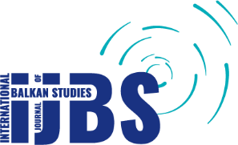

International Journal of Balkan Studies (IJBS),
University of New York Tirana
EU & Balkan Research Institute
Rr. Kodra e Diellit, Selitë,
Tiranë, Albania.

